Kubernetes Task 2

EKS cluster is created

Nginx yaml file

Nginx deployed

Expose the Nginx Application Outside the Cluster

Create a Service of Type LoadBalancer

To create the load balance service nginx-service.yaml created

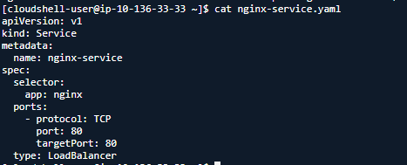

Trying to get external IP to check the accessibility from outside the cluster but still its pending due to AWS provisioning took so long.

